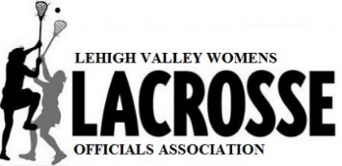
2023 YOUTH OFFICIALS TRAINING CLASS
Our training this year will take place VIRTUALLY for the classroom sessions. The on-field training following the classroom sessions will be scheduled for Saturdays in January/February. More information will be put forth in December.
You must be at least 14 years old to be a USAL youth official and follow the guidelines below:
- You must join USA Lacrosse as an official. Even though you may already be a member as a player, you will also need an OFFICIAL’S membership. When prompted to be affiliated with a chapter, please select Lehigh Valley.
- Return the attached form with proof of USL membership and the class fee to the address at the bottom of the application. Your check should be made out to LVWLOA (Lehigh Valley Women’s Officials Association).
- You cannot be scheduled for any of the sessions until you have completed these steps.
The USA Lacrosse guidelines and our instructional requirements are as follows:
- Attend the FIVE 90 MIN. classroom sessions as scheduled and THREE on-field training sessions. The classroom sessions must be completed before participating in the on-field training. Candidates will have access to online workbooks and materials from which weekly assignments will need to be completed prior to the next session to be prepared for the presentation.
- CLASSES WILL BE HELD VIA ZOOM on Wednesdays, November 9, 16, 30 and December 7, 14 from 8-9:30 pm. On-Field sessions will be on Saturdays in January/February, dates and times TBA. On-field sessions will be held at the ICE RINK on MacArthur Rd. in Whitehall.
- A whistle will be required for on-field sessions. A Fox-40 whistle is recommended. A whistle with a pea is not acceptable.
- You must also complete the annual USA Lacrosse rules exam upon completion of the on-field sessions (sometime in February). You can take this exam as many times as needed to gain a passing grade. We will also schedule a voluntary zoom session to go over the exam shortly after USAL publishes it.
- Attend the USL Youth Rule Interpretation zoom meeting. To Be Announced.
- The deadline for applications is November 1, 2022.
We appreciate your interest in Lehigh Valley girls’ lacrosse. If you have any questions, please email me. Any updates to the current information or need to cancel any class will be emailed directly to you and posted on our website.
Sincerely,
Joanna Blose, President, Lehigh Valley Women’s Lacrosse Officials Association;
Lehigh Valley USL Local Chair http://www.leaguelineup.com/welcome.asp?url=lvwloa
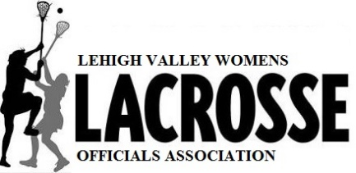
LVWLOA Officials TRAINING CLASS APPLICATION

Name:________________________________________________ Age:____________

Address:_____________________________________________________________________

Cell Phone:______________________________ Email: ________________________________

School or youth organization affiliation______________________________________________

What is your experience with lacrosse? (Please list any experience you have as a spectator, player, coach, or official of lacrosse and any other sport.)

Please return this form, proof of current USAL OFFICIAL’S membership, and $35 training fee by November 1, 2022 to:
Joanna Blose
314 S. 23rd Street
Allentown, Pa 18104

